**Module -1**

* **Create Database: Practice**
* **Create Table: tbl_products:**

insert into tbl_products values ('DVD',105.00,'LivingRoom')

insert into tbl_products values ('Microwave',98.00,'Kitchen')

insert into tbl_products values ('Monitor',200.00,'Office')

insert into tbl_products values ('Speakers',85.00,'Office')

insert into tbl_products values ('Refrigerator',900.00,'Kitchen')

insert into tbl_products values ('VCR',165.00,'LivingRoom')

insert into tbl_products values ('CoffeePot',35.00,'Kitchen')

select * from tbl_products

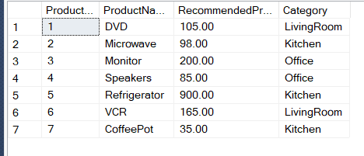

* **Create Table: tbl_customers:**

insert into tbl_customers values ('Chintan','Patel','Anand','GJ',388001)

insert into tbl_customers values ('Paresh','Prajapati','Nadiad','GJ',387001)

insert into tbl_customers values ('Pragnesh','Patel','Surat','GJ',395008)

insert into tbl_customers values ('Nilesh','Dharsandia','Mumbai','MH',400002)

insert into tbl_customers values ('Sonal','Patel','Mumbai','MH',400002)

insert into tbl_customers values ('Harshal','Patel','Mogri','GJ',388345)

insert into tbl_customers values ('Prakash','Rathod','Mogri','GJ',388345)

insert into tbl_customers values ('Aarzoo','Dodhiya','Rajkot','GJ',360003)

insert into tbl_customers values ('Heta','Dave','Varanasi','UP',221002)

insert into tbl_customers values ('Nikita','Dave','Varanasi','UP',221002)

insert into tbl_customers values ('Vaibhav','Dave','Varanasi','UP',221002)

insert into tbl_customers values ('Paresh','Patel','Pune','MH',411001)

insert into tbl_customers values ('Prakash','Patel','Pune','MH',411001)

insert into tbl_customers values ('Sandhya','Patel','Hyedrabad','AP',500031)

insert into tbl_customers values ('Divyesh','Patel','Banglore','KA',560002)

insert into tbl_customers values ('Payal','Shah','Banglore','KA',560002)

insert into tbl_customers values ('Priyanka','Rana','Anand','GJ',388001)

insert into tbl_customers values ('Sanket','Dhebar','V.V.Nagar','GJ',388121)

insert into tbl_customers values ('Puja','shah','Varanasi','UP',221002)

insert into tbl_customers values ('Priya','shah','Varanasi','UP',221002)

select * from tbl_customers

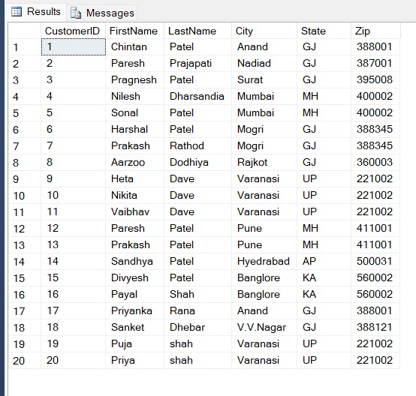

* **Create Table : tbl_sales :**

insert into tbl_sales values (1,1,130.00,'2005-06-14')

insert into tbl_sales values (2,2,97.00,'2005-06-19')

insert into tbl_sales values (3,3,200.00,'2005-09-20')

insert into tbl_sales values (4,4,80.00,'2005-03-22')

insert into tbl_sales values (5,5,899.00,'2005-01-23')

insert into tbl_sales values (6,6,150.00,'2005-03-24')

insert into tbl_sales values (3,7,209.00,'2005-03-10')

insert into tbl_sales values (4,8,90.00,'2005-08-11')

insert into tbl_sales values (6,9,130.00,'2005-08-12')

insert into tbl_sales values (2,14,85.00,'2005-12-13')

insert into tbl_sales values (3,15,240.00,'2005-05-14')

insert into tbl_sales values (1,17,87.00,'2005-07-19')

insert into tbl_sales values (2,18,99.00,'2005-09-20')

insert into tbl_sales values (6,19,150.00,'2005-07-22')

insert into tbl_sales values (5,5,900.00,'2005-03-06')

insert into tbl_sales values (4,6,86.00,'2005-04-07')

insert into tbl_sales values (2,7,88.00,'2005-11-08')

insert into tbl_sales values (3,8,198.00,'2005-05-09')

insert into tbl_sales values (1,9,150.00,'2005-10-10')

insert into tbl_sales values (6,14,99.00,'2005-05-09')

insert into tbl_sales values (6,15,104.00,'2005-09-20')

insert into tbl_sales values (4,14,90.00,'2005-07-22')

insert into tbl_sales values (1,1,130.00,'2005-03-06')

insert into tbl_sales values (2,2,102.00,'2005-04-07')

insert into tbl_sales values (1,3,114.00,'2005-11-08')

insert into tbl_sales values (5,4,1000.00,'2005-05-09')

insert into tbl_sales values (5,5,1100.00,'2005-10-10')

insert into tbl_sales values (3,6,285.00,'2005-06-11')

insert into tbl_sales values (2,7,87.00,'2005-10-12')

insert into tbl_sales values (3,8,300.00,'2005-07-13')

insert into tbl_sales values (3,20,205.00,'2005-12-31')

select * from tbl_sales

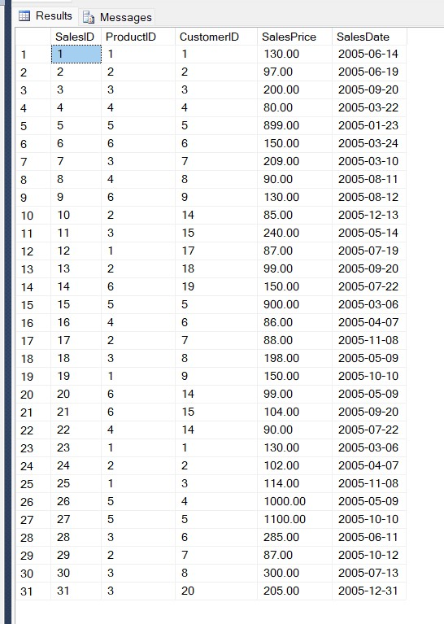

* **Queries :**

1. **Return the First Name, Last Name, Product Name, and Sale Price for all products sold in the month of October 2005.**
   * select

cust.FirstName,

cust.LastName,

prod.ProductName,

sal.SalesPrice

from

tbl_products prod

inner join

tbl_sales sal

on

prod.ProductID=sal.ProductID

inner join

tbl_customers cust

on

sal.CustomerID=cust.CustomerID

where

SalesDate between '2005-10-01'and'2005-10-31'

1. **Return the CustomerID, First Name, and Last Name of those individuals in the Customer table who have made no Sales purchases.**
   * select

cust.CustomerID,

cust.FirstName,

cust.LastName

from

tbl_customers cust

left outer join

tbl_sales sal

on

cust.CustomerID=sal.CustomerID

where

sal.CustomerID is null

1. **Return the First Name, Last Name, Sale Price, Recommended Sale Price, and the difference between the Sale Price and Recommended Sale Price for all Sales. The difference must be returned as a positive number.**
   * select

cust.FirstName,

cust.LastName,

sal.SalesPrice,

prod.RecommendedPrice,

prod.RecommendedPrice-sal.SalesPrice as difference

from

tbl_customers cust

inner join

tbl_sales sal

on

cust.CustomerID=sal.CustomerID

inner join

tbl_products prod

on

sal.ProductID=prod.ProductID

1. **Return the average Sale Price by Product Category.**
   * select

avg(sal.salesprice) as average_of_salesprice

from

tbl_products prod

inner join

tbl_sales sal

on

prod.ProductID=sal.ProductID

1. **Add the following Customer and Sale information to the database. (using store procedure)**

**FirstName: Priyanka**

**LastName: Chopra**

**City: Mumbai**

**State: MH**

**Zip: 400001**

**ProductID: 3**

**SalePrice: 205**

**SaleDate: 12/31/2005**

* + update tbl_customers

set FirstName='Priyanka',

LastName='Chopra',

City='Mumbai',

State='MH',

Zip=400001

from tbl_customers

inner join tbl_sales

on tbl_customers.CustomerID=tbl_sales.CustomerID

where SalesID=3

update tbl_sales

set ProductID=3 ,

SalesPrice=205 ,

SalesDate='2005-12-31'

from tbl_customers

inner join tbl_sales

on tbl_customers.CustomerID=tbl_sales.CustomerID

where SalesID=3

1. **Return the Product Category and the average Sale Price for those customers who have purchased two or more products.**
   * select prod.Category,

avg(sal.SalesPrice) as average_salesprice

from tbl_products prod

inner join tbl_sales sal

on prod.ProductID=sal.ProductID

group by Category

1. **Update the Sale Price to the Recommended Sale Price of those Sales occurring between 6/10/2005 and 6/20/2005.**
   * update

tbl_sales

set

SalesPrice = RecommendedPrice

from

tbl_products prod

inner join

tbl_sales sal

on

prod.ProductID=sal.ProductID

where

SalesDate between '2005-06-10'and'2005-06-20'

1. **Number of Sales by Product Category where the average Recommended Price is 10 or more dollars greater than the average Sale Price.**
   * select sal.SalesID,

avg(prod.RecommendedPrice) as recomm,

avg(sal.SalesPrice) as sales

from

tbl_products prod

inner join

tbl_sales sal

on

prod.ProductID=sal.ProductID

group by

SalesID

having

avg(prod.RecommendedPrice)>avg(sal.SalesPrice)

1. **Without using a declared iterative construct, return Sale Date and the running total for all sales, ordered by the Sale Date in Ascending Order.**
   * select SalesDate,

sum(SalesID) over (order by SalesDate asc) as total_for_all_sales

from tbl_sales

* **Create Database: Employee**
* **Create Table: tbl_employee:**

insert into tbl_employee values('Priya','1991-11-18','EEE',27500,'D1')

insert into tbl_employee values('Sandhya','1990-06-09','SA',25500,'D5')

insert into tbl_employee values('Prakash','1992-11-21','Accountant',29570,'D4')

insert into tbl_employee values('Divesh','1992-08-10','Supervisor',31000,'D3')

insert into tbl_employee values('Payal','1990-12-01','EEE',32000,'D7')

insert into tbl_employee values('Chintan','1991-04-25','SA',20500,'D9')

insert into tbl_employee values('Vaibhav','1993-06-22','Supervisor',22000,'D2')

insert into tbl_employee values('Paresh','1991-09-19','EEE',34000,'D5')

insert into tbl_employee values('Sanket','1996-11-01','EEE',37000,'D5')

insert into tbl_employee values('Nikita','1997-12-06','SA',38500,'D3')

select * from tbl_employee

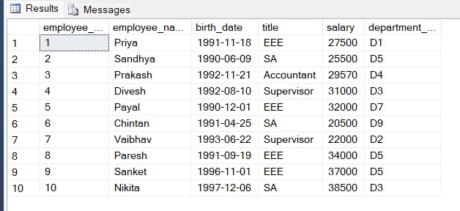

* **Create Table: tbl_proj:**

insert into tbl_proj values('Acme Corporation','$75000','D3')

insert into tbl_proj values('Annual Report','$100000','D1')

insert into tbl_proj values('Aurora Bridge Retrofit','$70000','D2')

insert into tbl_proj values('PBX Upgrade','$85000','D5')

insert into tbl_proj values('Risk Assessment','$12000','D8')

insert into tbl_proj values('Safety Procedures','$20000','D4')

insert into tbl_proj values('Software Localization','$125000','D9')

insert into tbl_proj values('Test Project','$70000','D5')

insert into tbl_proj values('Viaduct Redesign','$65000','D1')

insert into tbl_proj values('Intranet Site Refresh','$45000','D2')

select * from tbl_proj

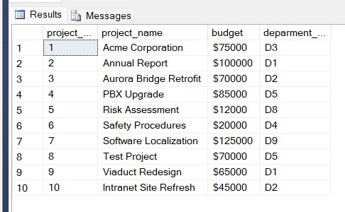

* **Create Table: tbl_dept:**

insert into tbl_dept values('D1','Finance',5)

insert into tbl_dept values('D2','Operations',3)

insert into tbl_dept values('D3','Sales',2)

insert into tbl_dept values('D4','It',10)

insert into tbl_dept values('D5','Administration',1)

insert into tbl_dept values('D6','Production',2)

insert into tbl_dept values('D7','Purchasing',6)

insert into tbl_dept values('D8','Services',8)

insert into tbl_dept values('D9','Management',9)

select * from tbl_dept

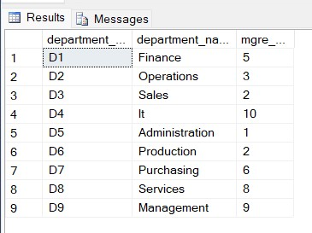

* **Create Table: tbl_workson:**

insert into tbl_workson values(1,5,'Manager',10)

insert into tbl_workson values(2,4,'Sales Manager',9)

insert into tbl_workson values(3,2,'Software Engineer',8)

insert into tbl_workson values(4,5,'Administrative Assistant',12)

insert into tbl_workson values(5,7,'Project Manager',7)

insert into tbl_workson values(6,8,'Chaiperson',10)

insert into tbl_workson values(7,10,'Chief Executive',8)

insert into tbl_workson values(8,5,'Senior Manager',12)

insert into tbl_workson values(9,4,'Group Leader',6)

insert into tbl_workson values(10,9,'Financial Advisor',10)

select * from tbl_workson

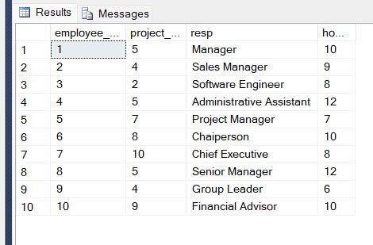

* **Queries :**

1. **Write an SQL query that returns the project number and name for projects with a budget greater than $100,000.**
   * select

project_no , project_name

from

tbl_proj

where

budget > '$100000'

1. **Write an SQL query that returns all works on records where hours worked is less than 10 and the responsibility is ‘Manager’.**
   * select * from

tbl_workson

where

hours < 10 and resp = 'Manager'

1. **Write an SQL query that returns the employees (number and name only) who have a title of ‘EEE’ or ‘SA’ and make more than $35,000.**
   * select

employee_no,

employee_name

from

tbl_employee

where

(title = 'EEE' or title='SA') and salary >35000

1. **Write an SQL query that returns the employees (name only) in department ‘D1’ ordered by decreasing salary.**
   * select

employee_name

from

tbl_employee

where

department_no='D1'

order by

salary desc

1. **Write an SQL query that returns the departments (all fields) ordered by ascending department name.**
   * select *

from

tbl_dept

order by

department_name asc

1. **Write an SQL query that returns the employee name, department name, and employee title.**
   * select

emp.employee_name,

dept.department_name,

emp.title

from

tbl_employee emp

inner join

tbl_dept dept

on

dept.department_no = emp.department_no

1. **Write SQL query that returns the project name, hours worked, and project number for all works on records where hours > 10.**
   * select

proj.project_name,

work.hours,

proj.project_no

from

tbl_proj proj

inner join

tbl_workson work

on

proj.project_no=work.project_no

where

hours > 10

1. **Write an SQL query that returns the project name, department name, and budget for all projects with a budget < $50,000.**
   * select

proj.project_name,

dept.department_name,

proj.budget

from

tbl_dept dept

inner join

tbl_proj proj

on

proj.deparment_no=dept.department_no

where

budget < '$50000'

1. **Write an SQL query that returns the employee numbers and salaries of all employees in the ‘Consulting’ department ordered by descending salary.**
   * select

emp.employee_no,

emp.salary

from

tbl_employee emp

inner join

tbl_dept dept

on

emp.department_no=dept.department_no

where

department_name='Consulting'

order by

salary desc

1. **Write an SQL query that returns the employee name, project name, employee title and hours for all works on records.**
   * select

emp.employee_name,

proj.project_name,

emp.title,

work.hours

from

tbl_employee emp

inner join

tbl_workson work

on

emp.employee_no=work.employee_no

inner join

tbl_proj proj

on

proj.project_no=work.project_no

* **Create Table: tbl_emp:**

insert into tbl_emp values('A',2)

insert into tbl_emp values('B',3)

insert into tbl_emp values('C',0)

insert into tbl_emp values('D',5)

insert into tbl_emp values('E',3)

select * from tbl_emp

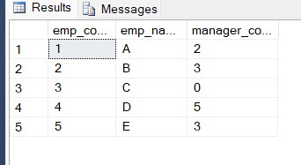

* **Create Table: tbl_manager:**

insert into tbl_manager values('D')

insert into tbl_manager values('C')

insert into tbl_manager values('C')

insert into tbl_manager values('B')

insert into tbl_manager values('A')

select * from tbl_manager

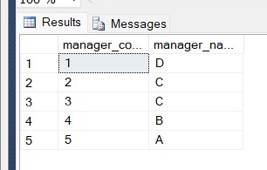

1. **Write an SQL query that returns the employee name their manager name by using manager code.**
   * select

emp.emp_name,

man.manager_name

from

tbl_emp emp

inner join

tbl_manager man

on

man.manager_code=emp.manager_code